PRAMOTING MODULE PROPERTIE TO APPLICATION PROPERTIES

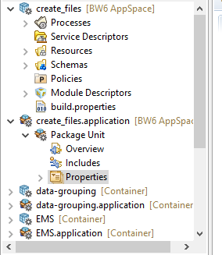

After Open The Properties Tab Then We Can see the Below Properties EG:-Like Blw

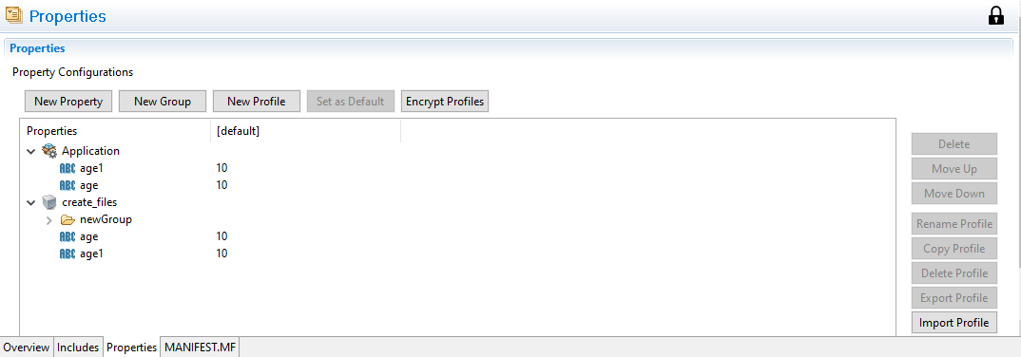

Then double click on the value of the proprties and click the up arrow button then it will propmote application level

